ST. LUKE’S C of E PRIMARY SCHOOL



SEND INFORMATION REPORT

Policy Date Review | March 2024
Date of next Review | March 2025
Reviewed by | Miss A Lawrence
Acting Headteacher | Miss S Dean
Chair of Governors | Pat Jones-Greenhalgh

‘Excellence through belief, inclusion and resilience’

This report was written in line with the 2015 SEND Code of Practice and St Luke’s CE Primary School’s SEND policy 2024/2025. Links to both of these documents are available on the school website.

What is the purpose of this information report?
The information below sets out what we do at St Luke’s CE Primary School to help ensure all pupils reach their potential.
What does this report include?
Section | Title | Pages
SECTION 1 | Contact details of SEND co-ordinators and SEND governor | 3
SECTION 2 | What types of SEND are catered for at St Luke’s CE Primary School? | 3
SECTION 3 | How are pupils with SEND identified? | 4
SECTION 4 | What is the approach to teaching pupils with SEND? | 5, 6 & 7
SECTION 5 | How do we assess children with SEND and SEND provision at St Luke’s? | 8
SECTION 6 | How does St Luke’s involve external agencies and provide transition for pupils with SEND? | 9
SECTION 7 | How are parents involved and supported during the SEND process? | 10
SECTION 8 | What do I do if I have a concern about the support or provision arrangements that are in place for my child? | 11
Appendices | St Luke’s SEND Flowchart | 13

Section 1: Contact details of SEND co-ordinator and governor
Special Educational Needs Co-ordinators (SENCO)
Miss Anna Bolton
Miss Amy Lawrence
Parent Support Advisor and member of SEND Team
Mrs Jane Slater
Special Educational Needs and Disability (SEND) Governor
Mrs Mariam Latif
Contact details for SENCOs and SENCO Governor
Telephone: 0161 764 4988
Email: stlukes@bury.gov.uk

Section 2: What kinds of SEND are provided for at St Luke’s?
“A pupil has SEN where their learning difficulty or disability calls for special educational provision, namely provision different from or additional to that normally available to pupils of the same age.”
(SEND CofP June 2014: 94 - 95)

“A pupil has a disability if they have ‘…a physical or mental impairment which has a long-term and substantial adverse effect on their ability to carry out normal day-to-day activities’.
(Equality Act 2010: 7)
Our school currently provides additional and/or different provision for a range of needs including:
- Communication and interaction, for example Autistic Spectrum Disorder (ASD)
- Cognition and learning, for example Dyslexia
- Social, emotional and mental health difficulties, for example Attention Deficiency Hyperactivity Disorder (ADHD)
- Sensory and/or physical needs, for example visual or hearing impaired.

Section 3: How are pupils with SEND identified?
A: HOW DOES THE SCHOOL KNOW IF MY CHILD NEEDS EXTRA HELP?
Definition of SEN
A pupil has SEN if they have a learning difficulty or disability which calls for special educational provision to be made for them.
They have a learning difficulty or disability if they have:
- A significantly greater difficulty in learning than the majority of the others of the same age, or
- A disability which prevents or hinders them from making use of facilities of a kind generally provided for others of the same age in mainstream schools
Special educational provision is educational or training provision that is additional to, or different from, that made generally for other children or young people of the same age by mainstream schools.

The "Notice, Check, Try" model is a process used by classroom practitioners to identify and address concerns regarding children at St Luke’s. This is the pre-graduated approach and the first step to identifying what the child’s need may be.
- Notice: This involves observing and recognising signs that a child may be experiencing difficulties, such as withdrawal or frequent absences.
- Check and Try (Early Intervention): Classroom practitioners then check with the child, their parents/family, and colleagues to gather information. They listen actively to the child's perspective, take their input seriously, and act reasonably on their concerns. The teacher will then try different approaches to support the child and monitor them for up to two terms.
This early intervention phase doesn't necessarily mean the child has special educational needs (SEN) but aims to resolve concerns swiftly. It's about building trusting relationships, involving families, and seeking support from various agencies like education, social care, and health.
Throughout this process, schools collaborate with various agencies to address underlying needs. Comprehensive recording systems ensure that if a child enters the graduated approach, there's enough information to determine if they require special educational provision.

At St Luke’s C E Primary school children are also identified as having Special Educational Needs (SEN) through a variety of methods including:
- Liaison with previous school/nurseries
- Regular monitoring of achievement
- Concerns raised by parents
- Concerns raised by school staff
- Liaison with health professionals and outside agencies e.g. Speech and Language Therapists, Healthy Young Minds, Paediatricians, Educational Psychologists etc.
We also follow a four stage graduated approach to identification which follows the SEND 2015 Code of Practice. A step-by-step guide to the process of identifying and supporting children with SEND at St Luke’s can be found in appendix 1. The graduated approach can be found on our school website through the following link: https://www.stlukesbury.co.uk/send/

B) WHAT SHOULD I DO IF I THINK MY CHILD HAS SPECIAL EDUCATIONAL NEEDS?
A parent may meet with the class teacher, SENDCO or Headteacher at any time if they have concerns about their child’s education.

Section 4: What is the approach to teaching pupils with SEND?
- HOW WILL WE ASSESS THE NEEDS OF PUPILS WITH SEND?
We will assess each pupil’s current skills and level of attainment on entry, which will build on previous settings and key stages where appropriate. We measure all children’s progress in learning against national and age related expectations. Class teachers continually assess each child and note where extra support may be required, formal assessments are carried out termly, for example if a child is working significantly slower than their peers. This may also include progress in areas other than attainment, for example social needs. Children who are not making expected progress are identified in pupil progress meetings and strategies are then deployed to enable the child to progress.

- HOW WILL THE SCHOOL STAFF SUPPORT MY CHILD?
In St Luke’s, there are a number of people who could be working with your child to provide the best educational opportunities. Parents will be invited into school so we can discuss their child’s progress on a termly basis.
- SPECIAL EDUCATIONAL NEEDS AND DISABILITY COORDINATORs (SENDCO) –Miss A Bolton, Miss A Lawrence & Mrs Jane Slater Contact details: 0161-764-4988.
The SENDCO is responsible for coordinating all the support for children with SEND and for developing the school SEND Policy to ensure all children get a consistently high quality response to meeting their needs within school. Anna Bolton, Amy Lawrence and Jane Slater hold the NASENDco award.
- CLASS TEACHER
The class teacher is responsible for planning, adapting and monitoring work for each child with SEND in their class to ensure progress is made.
- SUPPORT ASSISTANT
Some children may have a Support Assistant working either individually or as part of a group with them to support their needs.
- HEADTEACHER – Melanie Michael
The Headteacher has overall responsibility for ensuring that the educational needs of all children within school are met and any issues in relation to SEND are reported to the Governing Body.
- SEND GOVERNOR – Maryam Latif
This governor is responsible for ensuring the school has an up to date SEND policy and ensuring that the school has appropriate provision for all pupils. They will also visit school to understand and monitor the support SEND children receive.

- HOW WILL THE CURRICULUM BE MATCHED TO MY CHILD’S NEEDS?
All class teachers will adapt the work set for each lesson to ensure all children will be able to access the curriculum according to their individual needs.
Where appropriate a School based plan (SBP) will be produced and shared with parents/carers and the child to support their learning needs. A School based plan is a detailed plan that sets out targets and strategies to help your child learn. It will usually contain three or four individual, short-term targets for your child to focus on. The targets may relate to aspects of the curriculum (literacy, numeracy, etc) and/or they may focus on other areas such as engagement in class, behaviour or social skills. The SBP will specify what will be taught to your child, what resources and strategies will be put in place, and these should be based on your child’s individual needs.

- HOW DOES SCHOOL ADAPT THE CURRICULUM AND LEARNING ENVIRONMENT?

- Differentiate our curriculum to ensure all pupils are able to access it. For example, by grouping, teaching style and the content of the lesson.
- Adapting of resources and staffing, for example using laptops to assist learning, visual timetables, PECs cards (picture cards which can be used instead of verbal communication), enlarged texts, sensory areas, Bi-lingual support staff to assist children whose first language is not English.
- Differentiating the teaching styles for example, longer processing time for pupils who may need it, pre-teaching for topic and vocabulary work.
- PE curriculum is adapted to support children with physical disabilities.
- School is accessible to wheelchair users.
- School has a lift to our first floor teaching areas.
- Accessible toilet facilities.

- WHAT IS OUR APPROACH TO SUPPORTING SEND NEEDS?
Teachers are responsible and accountable for the progress and development of all the pupils in their class.
Quality-first teaching is our first step in responding to pupils who have SEN. Adaptive teaching techniques will be put in place for individual pupils and modifications and adaptations can be made. This may include using coloured reading overlays to support reading, word mats to encourage the understanding of new vocabulary or sloped writing boards to support writing difficulties. We then use a number of different interventions and support programs to support our SEN pupils.

- WHAT SUPPORT WILL THERE BE FOR MY CHILD’S OVERALL WELLBEING?
St Luke’s is an inclusive school that aims to provide for every child. In order to achieve this we employ a pastoral team which consists of SEND support workers and Parent Support Advisors to support both the child and the parent. To address issues that may present a barrier to learning, we will also refer to external agencies to support where it is required.
The school has a policy for administering medication and the managing of medicines on the school site. Parents are asked to complete a medical questionnaire on behalf of their child at the start of each academic year. Staff have regular training on managing various medical conditions and have tailored training on safe handling procedures.
The school adopts a positive recognition approach to behaviour with a clear reward system operated by all staff members. St Luke’s also operates a zero tolerance approach towards bullying. The school recognises its legal duty under the Equality Act 2010 to prevent pupils with a protected characteristic from being at a disadvantage. Consequently, our approach to challenging behaviour may be differentiated to cater to the needs of the pupil. If a child has specific behavioural issues, an Individual Behaviour Management Plan is created in consultation with the parents and the child to cover both home and school situations. Any form of exclusion from school is taken as a last resort.
Attendance of each pupil is monitored daily and any concerns raised with the Attendance Team weekly. An incentive scheme for attendance is in place which has reduced the number of late arrivals.
The school has a robust safeguarding system in place for our children and this includes all staff members receiving annual safeguarding training for managing day to day issues. The designated safeguarding team receive level 3 training annually.
The school also provides weekly counselling session for certain individuals and peer mediation sessions. The school council meets termly and discusses any issues raised by the pupils.

Section 5: How do we assess children with SEND and SEND provision at St Luke’s?
- HOW WILL WE ASSESS AND REVIEW PUPIL’S PROGRESS TOWARDS OUTCOMES?
St Luke’s operates an open door policy where parents are welcome to make an appointment to meet with either the class teacher or the SENDCO to discuss their child’s progress. School staff can also offer advice and practical ways to help you support your child at home. We believe that a child’s education should be a partnership between parents and school and therefore aim to keep communication channels open and effective. Where appropriate, parental training sessions may be offered within school to aid support for the children.
We will follow the graduated approach and the four part cycle of assess, plan, do, review. If your child has a School based Plan (SBP) we will set SMART (Specific, Measured, Achievable, Realistic, Time scaled) targets with the expectation that your child will achieve the targets by the review date. If a target is not met within the time scale the reasons are discussed and the target may be adapted into smaller steps or a different approach to ensure progress is made. Our graduated process of support can be found in the SEND section of the school website at: https://www.stlukesbury.co.uk/send/
If your child has an Educational Health Care Plan or EHC plan, a formal meeting will take place annually with a report to discuss your child’s progress and the way forward.

- HOW WILL SCHOOL EVALUATE THE EFFECTIVENESS OF THE SEND PROVISION?
We evaluate the effectiveness of provision for pupils with SEND by:
- Reviewing pupil’s individual progress towards their goals each term
- Reviewing the impact of interventions after a set period of time
- Monitoring by the SENDCO
- Using provision maps to measure progress
- Holding annual reviews for pupils with EHC plans

- WHAT EXPERTISE AND TRAINING OF STAFF WILL BE CARRIED OUT TO SUPPORT CHILDREN AND YOUNG PEOPLE?
Book looks and lesson observations by the Senior Management Team ensure the needs of SEND pupils are being met effectively. Outcomes from lesson observations and analysis of pupil voice and pupil books feed into a yearly training programme led by Senior Leaders. Training programmes are delivered in school to ensure all staff are confident and competent in delivering high quality interventions. The expertise of the SENDCO is used to support staff in a mentoring style role.
Staff are kept updated with new legislation and policy in line with government guidelines. Outside agency support provide training for all staff where necessary.
All staff that are in regular contact with children are qualified in administering first aid; several members of staff are ‘Team Teach’ trained to support behaviour. We hold annual medical training for epi pen and asthma. All of our Support Assistants are included in Continual Professional Development (CPD) programmes.
Staff have a range of skills and qualifications which include degrees in SEND and inclusion, safe school behaviour and management training, CPD training such as Autistic Spectrum Disorder and outreach support and training from specialist provisions.
Staff also have access to the Bury SEND Graduated Approach Toolkit, which is designed to offer guidance and support to improve inclusion in educational settings and remove barriers to learning through reasonable adjustments and high quality teaching and targeted support as part of a ‘graduated approach’ to SEND. Access to this can be found through the following link: https://theburydirectory.co.uk/bury-send-graduated-approach

Section 6: How does St Luke’s involve external agencies and provide transition for pupils with SEND?
- HOW DOES SCHOOL LIASE WITH EXTERNAL AGENCIES TO MEET THE NEEDS OF CHILDREN AND FAMILIES?
The school works closely with external agencies that are relevant to individual children’s needs including; School Nursing Service, Educational Psychologist, Speech and Language Therapists, Hearing Impairment Team, Visual Impairment Team, Occupational Therapists, First Language Support, Multi-agency Safeguarding Hub, Children’s Services, Healthy Young Minds, The Additional Needs Team, Bury First point and Paediatricians and a private counsellor.
If it is felt that a child would benefit from one of these services, a referral is made by school. Once the referral is made, the external agency will contact parents and school to discuss further options for support.

- HOW CAN MY CHILD ACCESS SCHOOL TRIPS AND EXTERNAL EVENTS?
All educational visits are risk assessed and aim to be as fully inclusive as possible, including residential trips. Parents will be consulted prior to an external event to assess a child’s individual needs, in some cases parents are invited to attend trips in order to further support their child.
All of our extra-curricular activities are available to all our pupils including breakfast club and after school clubs. All pupils are encouraged to take part in sport’s day, school plays/special workshops.
No pupil is ever excluded from taking part in these activities because of their SEND.

- WHAT ARRANGEMENTS ARE THERE FOR SUPPORTING CHILDREN MOVING BETWEEN PHASES OF EDUCATION AND PREPARING FOR SECONDARY SCHOOL?
We have an extensive transition programme in place for both pupils joining the school and those moving on. All new children are encouraged to visit school before starting in any year group. Our Nursery staff make home visits prior to children starting in Nursery. For children with SEND, we encourage further visits to assist in the transition to our school. Where appropriate we will visit new pupils in their current educational setting. For children preparing to leave us for a new school, we ensure that their key support worker attends with them. For transition to Secondary school we arrange extra transition visits for vulnerable children. We would meet with the Secondary SENDCO and support team to carry out a full handover. We have developed close links with all our local Secondary Schools and Specialist Provision to minimise the impact of transition for our pupils.

Section 7: How are parents involved and supported during the SEND process?
- HOW IS THE DECISION MADE ABOUT WHAT TYPE AND HOW MUCH SUPPORT MY CHILD WILL RECEIVE?
If a child has an EHC plan, this will determine the level of support and resources the child requires. Targets are specified for short, medium and long term aims and these are supported with appropriate allocation of staffing and resources.
For those children who do not have an EHC plan, the class teacher will liaise with the SENDCO and parents to discuss individual needs and arrange appropriate support. Children will be given the opportunity to express their views and interests which will be incorporated into the teacher planning. Targets are reviewed regularly to ensure outcomes are being met.
- HOW ARE PARENTS AND PUPILS CONSULTED AND INVOLVED?
At St Luke’s, parents are encouraged to talk to staff about any concerns they have with regard to their child’s education. We recognise that parents and school are joint educators and that information should flow freely between both sides. We will have an early discussion with the child and their parents/carer when identifying whether they need special educational provision. These discussions will provide a good understanding of the child’s areas of strength or difficulty and will take into account the parent’s concerns. Termly person centred reviews are held with parents and pupils where appropriate to discuss progress and future targets.
Pupils are fully involved with their learning and those pupils with a high level of SEND need are using one page profiles so we can make sure we understand what is important to each child and how they would like to be supported.
Section 8: What do I do if I have a concern about the support or provision arrangements that are in place for my child?
- WHO CAN I CONTACT FOR FURTHER INFORMATION?
The first point of contact if you have any concerns about your child’s information is the class teacher. You can also arrange to meet with the school’s SENDCO who will be happy to meet with you to discuss any concerns.
Here is the link to Bury Local Authority local offer. Here you will find a wealth of information about how Bury can support you and your child with their SEND needs. Local authority local offer
Here are other school documents that you may find useful:
- Accessibility Policy
- Behaviour policy
- Medicine Policy
- SEND Policy
- HOW WOULD I RAISE A COMPLAINT?
Complaints about SEND provision should be made to The Headteacher, Miss M Michael, in the first instance. They will then be referred to the school’s complaint’s policy.
The parents of pupils with disabilities have the right to make disability discrimination claims to the first tier SEND tribunal if they believe our school has discriminated against their child. They can make a claim against alleged discrimination regarding:
- Exclusion
- Provision of education and associated services
- Making reasonable adjustments, including the provision of aids and services

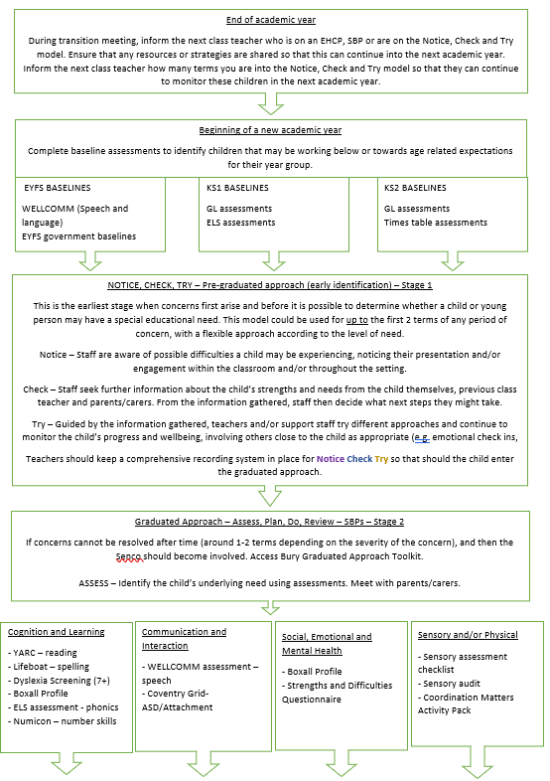
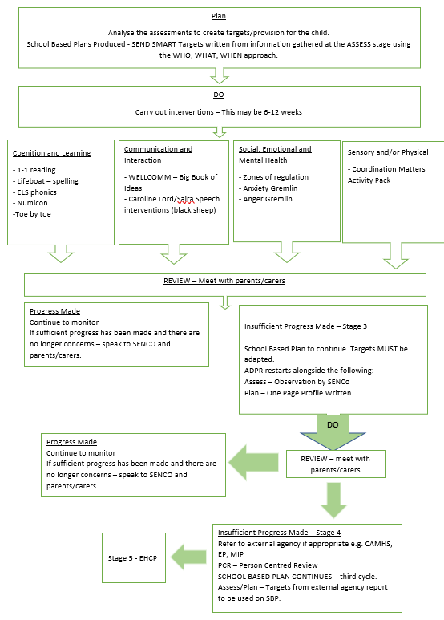
Appendix 1 – St Luke’s SEND Flowchart
Stage 5: Apply for EHCP

